**Advance Excel Assignment 1**

1. What do you mean by cells in an excel sheet?

A cell is an essential part of MS-Excel. It is an object of Excel worksheets. Whenever we open Excel, the Excel worksheet contains cells to store the information in them. We enter content and our data into these cells. Cells are the building blocks of the Excel worksheet.

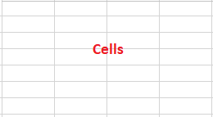

In the Excel worksheet, a cell is a rectangular-shaped box. It is a small unit of the Excel spreadsheet. There are around 17 billion cells in an Excel worksheet, which are united together in horizontal and vertical lines.

An Excel worksheet contains cells in rows and columns. Rows are labelled as numbers and columns as alphabets. It means the rows are identified by numbers and columns by alphabets.

**Spreadsheet Cell Types**

Cells hold four types of information (also called data types):

* Numbers that can include formulas, dates, and times.
* Text, often referred to as text strings or just strings.
* Boolean values of TRUE or FALSE.
* Errors including #NULL! #REF!, and #DIV/0! that indicate a problem.

1. How can you restrict someone from copying a cell from your worksheet?

3 ways to protect excel sheet from copy-paste

* **Use Info Option to Protect Excel Sheet from Copy-Paste**

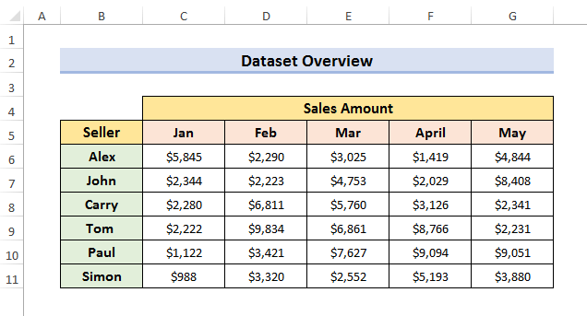The easiest way to protect our sheet from copy-paste is to use the ‘**Info**’ option. To explain this method, we will use a dataset that contains the sales amount of the first five months of some sellers. We will discuss two sub-methods here.

* **Secure Workbook with password**

You can secure the workbook with a password to protect it from copy-paste. Whenever someone tries to open your sheet, excel will ask for the password. If anybody enters the wrong password, the excel sheet will not open. You must use this if your workbook contains very important pieces of information.

**STEPS:**

* First, go to the **FILE**tab at the left-top corner of your screen.

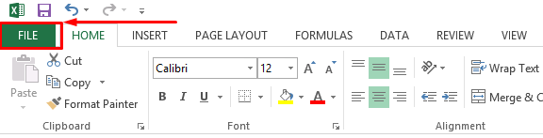

* Second, select **Info.**
* Third, select **Protect Workbook**and then, select **Encrypt with Password.**

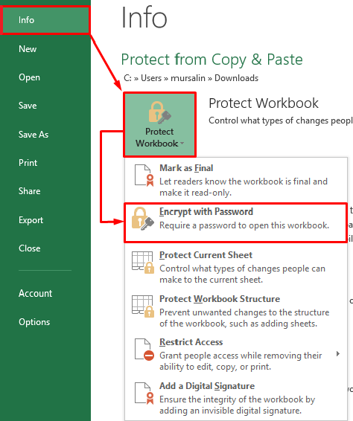

* Now, the **Encrypt Document**window will appear.

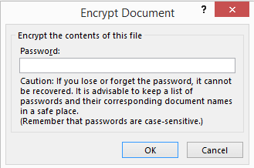

* After that, type the password you want to set and click **OK.**

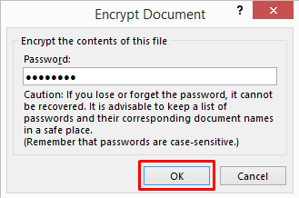

* Re-enter the password to confirm and again, click **OK.**

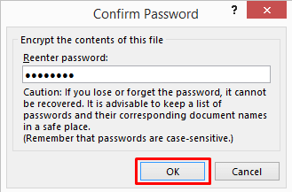

* Finally, if someone opens your workbook, it will show a message like below.

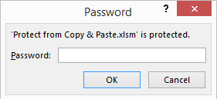

* **Make excel sheet read-only**

We can also protect our excel sheet from copy-paste by making it read-only. Anybody can open a read-only excel file but it will display a message to prevent users from copy-pasting or editing. To do so, follow the steps below.

**STEPS:**

* In the beginning, go to the **File**tab and select **Info.**
* Then, select **Protect Workbook**and then, select **Mark as Final.**

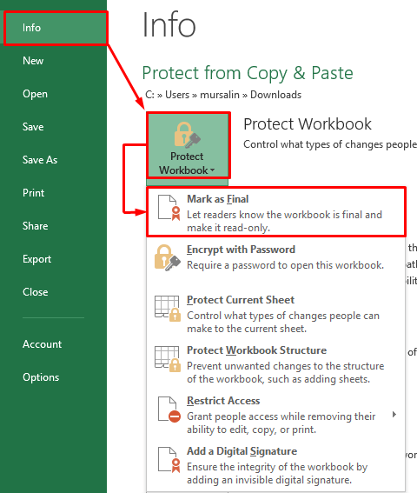

* Now, **Microsoft Excel**will open. Click **OK**to proceed.

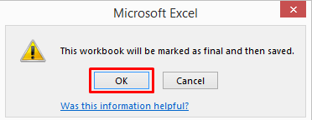

* Finally, if someone opens the file, he/she will see a message at the top of the sheet.

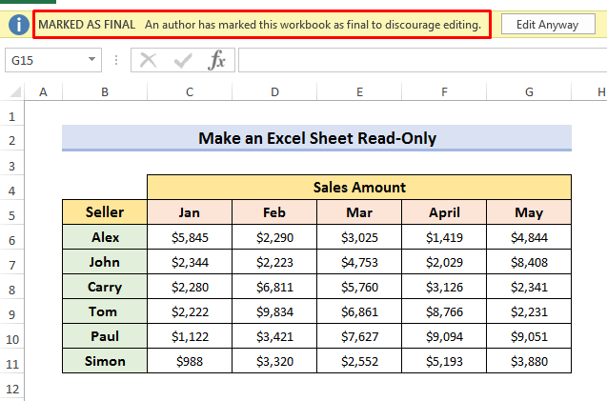

* **Prevent Excel sheet from copy-paste from review tab**

We can also use the **REVIEW**tab to protect your sheet from copy-paste. This method is very helpful if we want to protect a single sheet or individual sheets in our workbook. Let’s follow the steps to learn more about this technique.

**STEPS:**

* In the first place, go to the **Review**tab and select **Protect Sheet.**

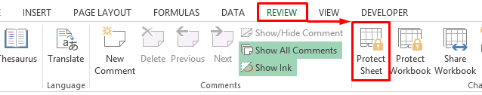

* Secondly, a **Protect Sheet**window will occur. Type the password you want to set. Click **OK**to proceed.

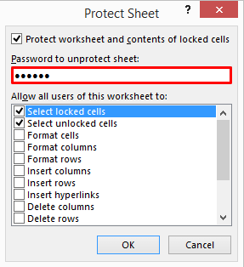

* Finally, re-enter the password to confirm.

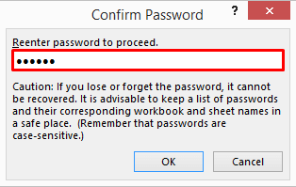

* Now, if someone wants to copy-paste, excel will show a message like this.

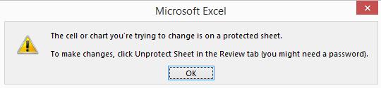

* To unprotect the sheet, go to the **Review**tab and select **Unprotect Sheet.**

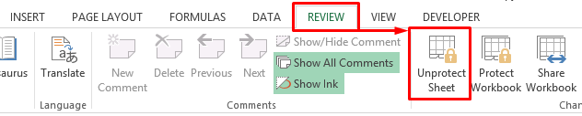

* Type your password and click **OK**to unprotect the sheet.

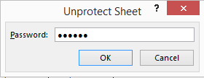

* **Lock cells to secure an excel sheet from copy**

Sometimes, we need to protect some specific cells so that others cannot copy-paste them. We can also lock all cells to protect our worksheet from copy-paste. This method is more useful when you want to lock some specific cells.

**STEPS:**

* Click the [**Select All**](https://support.microsoft.com/en-us/office/select-all-cells-on-a-worksheet-1a35f997-7afa-4656-bd06-c8086765fccf)button at first.

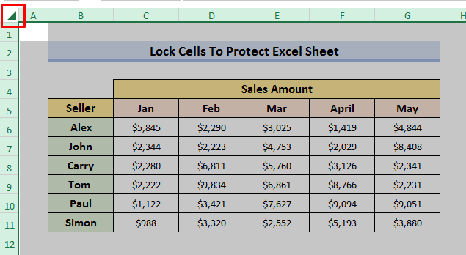

* 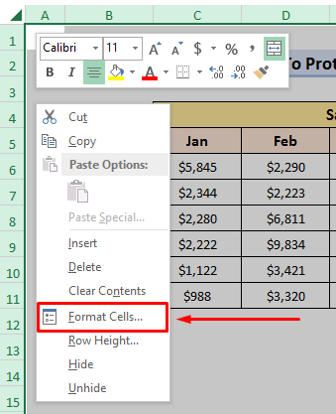Now, **right-click** your mouse and select **‘Format Cells’**from the drop-down menu.
* Then, the **Format Cells**window will occur.

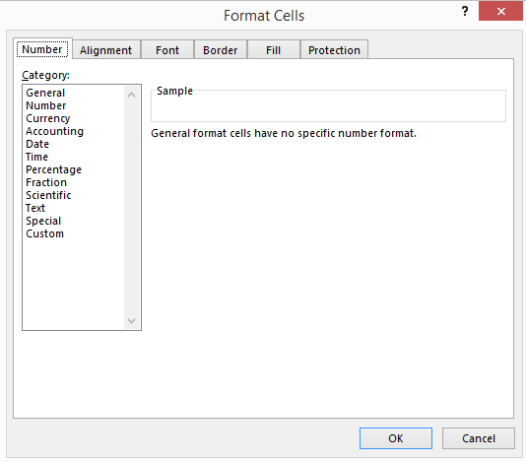

* After that, go to **Protection**and check the **Locked**Click **OK**to proceed.

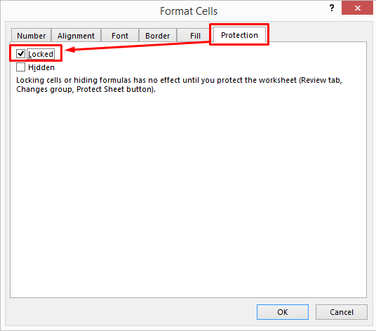

1. How to move or copy the worksheet into another workbook?

To copy a worksheet from one Excel workbook to another using Excel’s user interface, do the following:

* Open the source and the target workbook. The source workbook contains the worksheet you want to copy or move; you’ll be moving or copying the source worksheet to the target workbook. Both workbook files must be open. Use the demonstration file as the source workbook to follow along. Open a second workbook to act as the target. Any workbook file will do, even if it’s a new blank workbook.
* In the source workbook, navigate to the sheet you want to copy or move.
* Right-click the sheet tab in the source workbook and choose Move Or Copy from the resulting shortcut menu, as you did in the last section.
* In the Move Or Copy dialog, choose the target sheet from the To Book dropdown. Excel will display only open workbooks in this list.
* If you want to copy rather than move the sheet, click the Create A Copy option at the bottom of the dialog

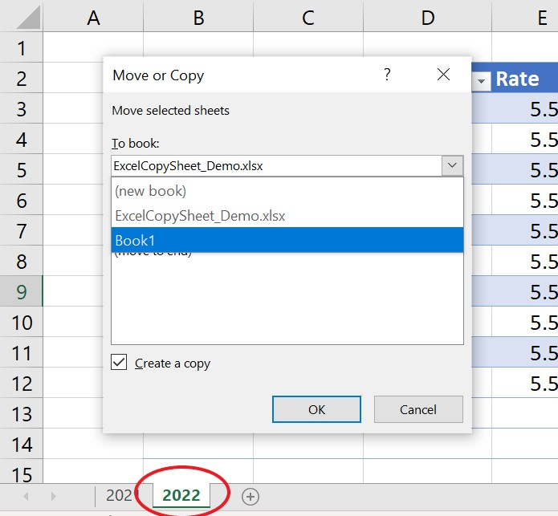

* Click OK, and Excel will move or copy the sheet to the target workbook.

1. Which key is used as a shortcut for opening a new window document?

Ctrl+N is a shortcut key used to most often used to create a new document, window, workbook or another type of file.

1. What are the things that we can notice after opening the Excel interface?

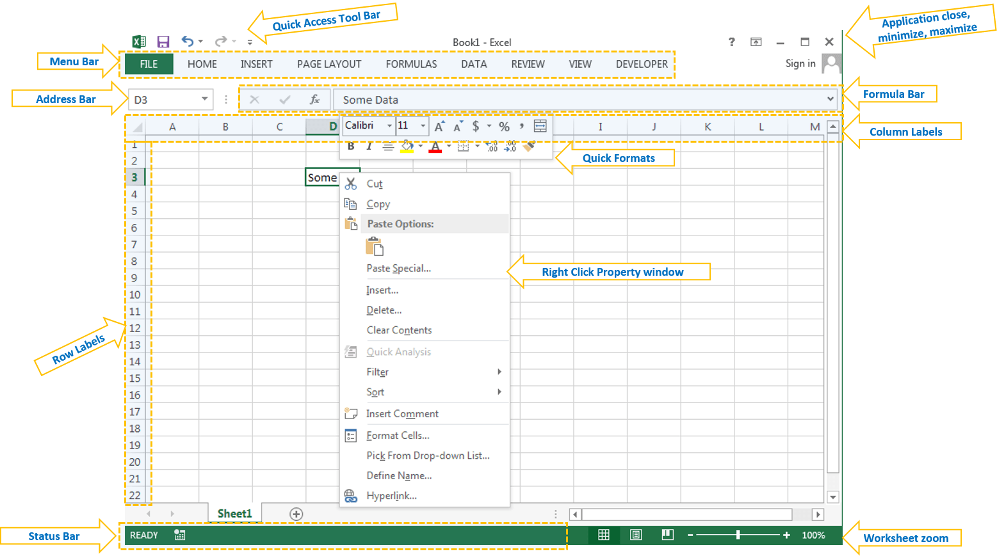

* **Menu Bar or Ribbon:** Here you can find different verities of utilities to deal with Excel to do our jobs
* **Address Bar:** We can see the active Cell, Range or Object Name here. You can type any name of the object to activate it
* **Formula Bar:** We can write a formula in Cell or Object using Formula Bar
* **Application or Windows Button:** We can use this to minimize, maximize or close the application
* **Status Bar:** Where you can see the status of the Application task, we can print status using VBA
* **Zoom:** We can increase or decrease the zoom levels of the worksheets
* **Quick Access Tool Bar:** We can assign any utility to quickly access it

**OBJECTS IN EXCEL**

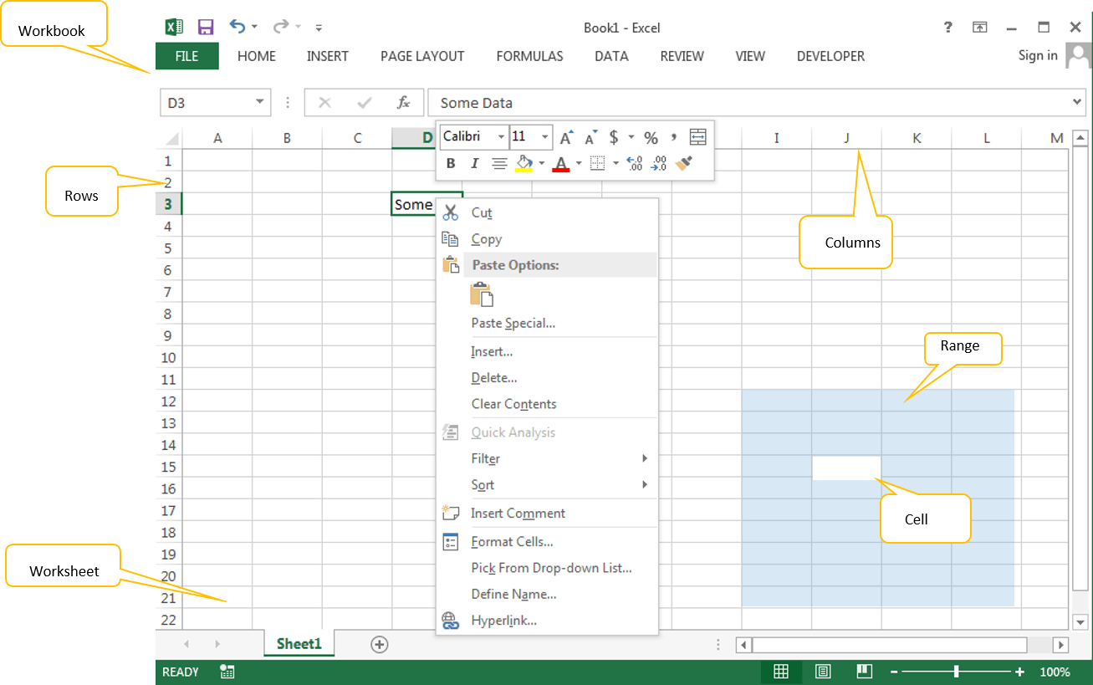

* **Workbook:** It is the main file, which we can give name and store it in desired folder. All other objects are part of this workbook
* **Worksheet:** It is the space where we can enter our data and format. A workbook is a collection of worksheets
* **Cell:** Cell is the part of the worksheet, where we enter the data, formulas.
* **Range:** It is a collection of Cells in excel worksheet.
* **Rows:** These are records (1,2,3,4…) in excel worksheet.
* **Columns:** These are Fields (A, B,C,D,…) in excel worksheet.

1. When to use a relative cell reference in excel?

Relative reference is a type of cell reference in Excel. This reference changes when the formula is copied to any other cell or any other worksheet. Relative cell references are used whenever calculations need to be repeated.

For instance, in cell A1, we have “=B1+C1.” On copying this formula to cell B2, the formula becomes “=C2+D2.” This is because the first formula refers to two cells on the right of cell A1 while the second formula refers to two cells on the right of cell B2. Cells B1 and C1 are to the right of cell A1 and cells C2 and D2 are to the right of cell B2.

Relative cell reference is used whenever calculations need to be repeated.